# **Lab4_AR**

# Created on November 23 2020

# **Table of Contents**

1.0. Home

2.0. Artist

3.0. Contact Us

# **1.0. Home**

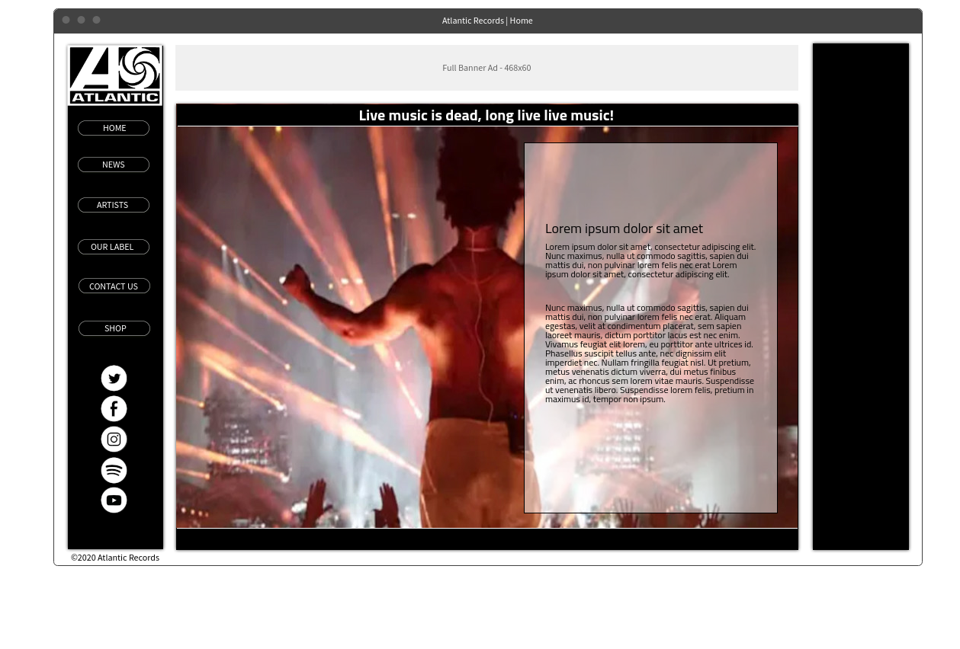

# **2.0. Artist**

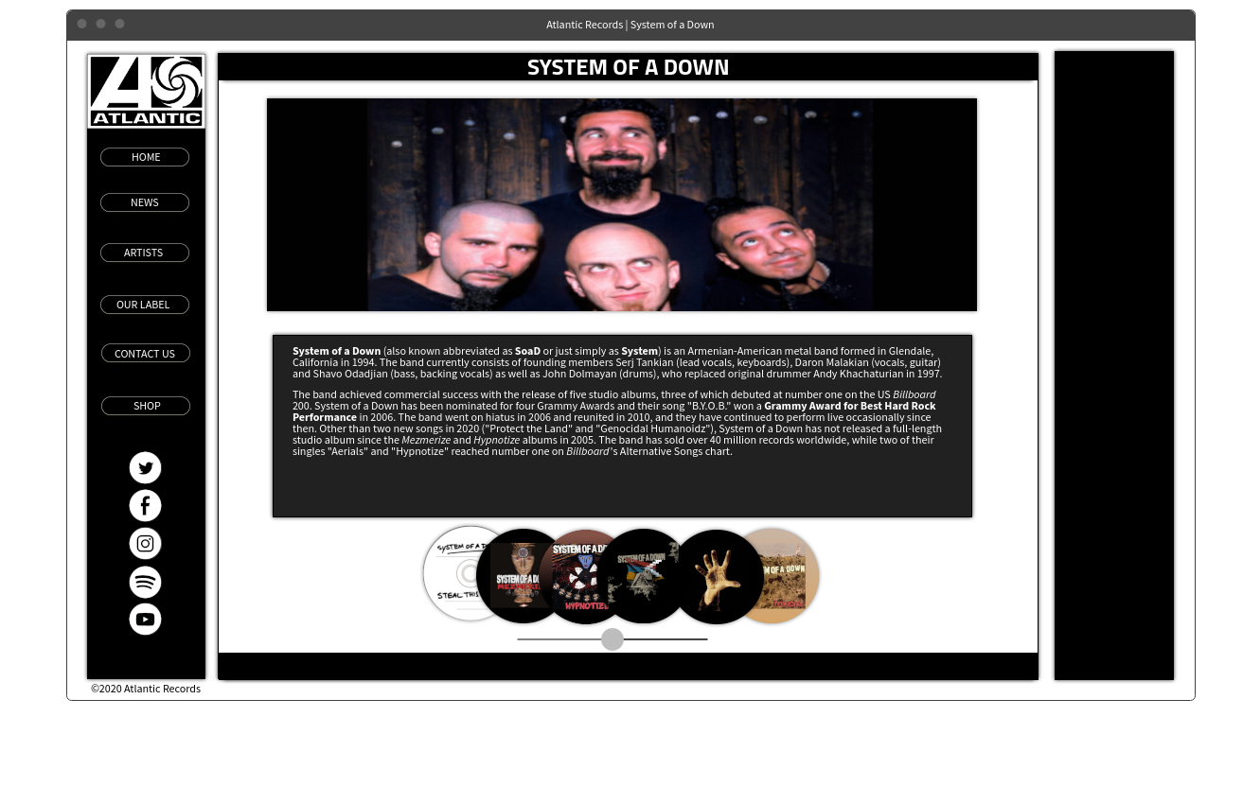

# **3.0. Contact Us**

